ENGN4615 Design Assignment

Patrick Wilton | u6050506

11th October 2019

# Design Problem 1

This design problem deals with finding the stress concentration factors for two separate radii on a material part due to a 4.5 kN load applied at its end. These stress results are to be compared with classical beam theory results using a uniform depth and the original part dimensions. Standard mild steel will be used as the material.

The following figure describes the dimensions of the part including the two radii needed for stress analysis:

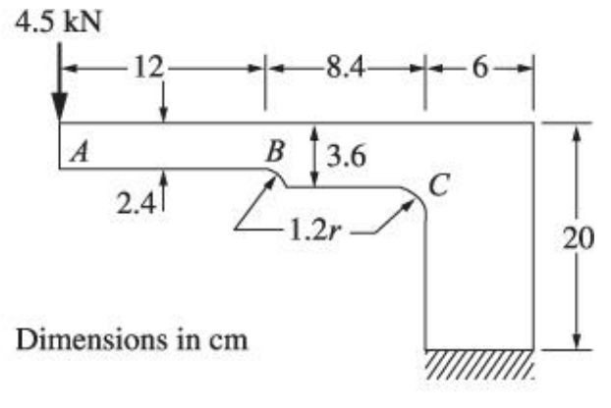

Figure : Dimensions for part used in Design Problem 1

# Design Problem 2

# Design Problem 3